To use a Microsoft Office 365 Email (“Microsoft”) within Maestro to send to your patients, a few changes need to be made within your Microsoft account for this to be possible.

Things you will need:
- Access to your Microsoft account.
Per Microsoft security measures, these steps must be followed within your Microsoft account or Microsoft will likely not work within Maestro. These changes are not at our control and are subject to change at Microsoft’s discretion.
There are two parts to this process, one will happen in Microsoft, one in Maestro.
Part One:
- Go to https://account.microsoft.com/security. You will have to be logged in to access this page, but if you are not already, it will prompt you to do so. Please be sure to log into the account you wish to use for emailing.
- Check to make sure you have Two-step Authorization turned on. If you do not, please go through the online steps to make this active, otherwise you will not be able to setup an app password
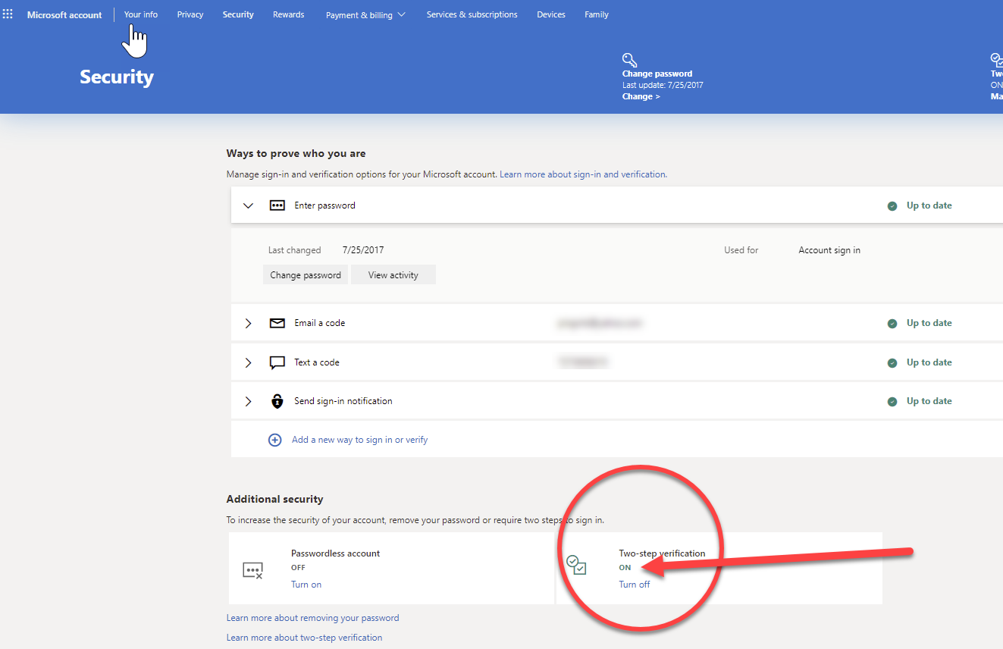

- Once Two-step verification is turned on, or if it already was, in the “App passwords” section, select “Create a new app password”
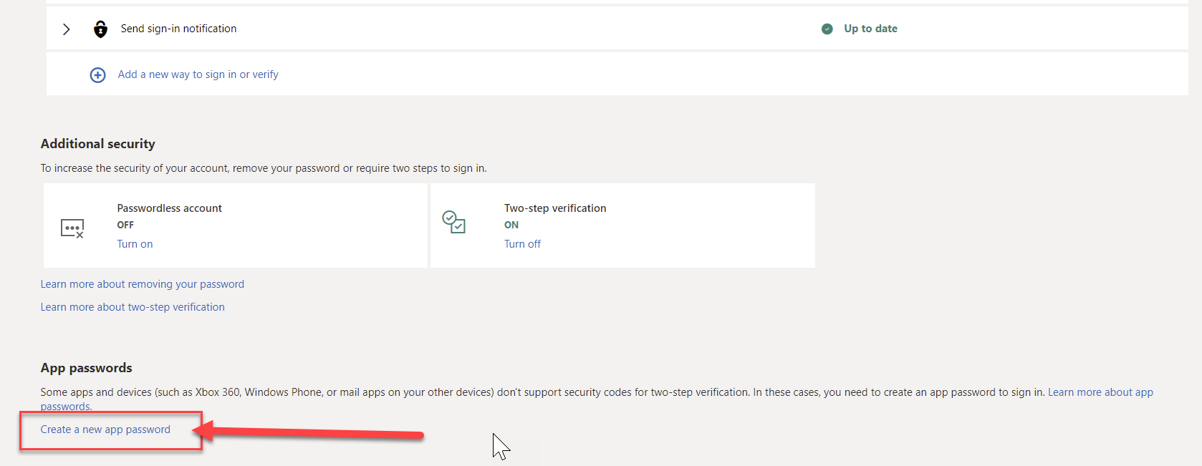
- Stop here. We recommend you write it down the password. Alternatively, you may simply copy and paste it into the appropriate field in Maestro (see following steps)
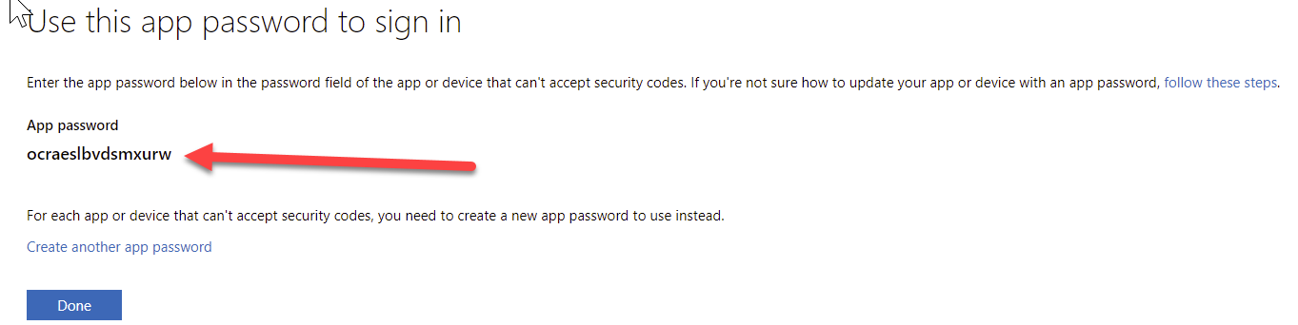
- Once you have written down the password, select Done

Part Two:
To use Microsoft in Maestro, the email account you use in Maestro must be a Microsoft address. (Before proceeding below, check this by going to Setup and Organization).
- In Maestro, select “Setup” on the top menu bar.
- Select “Settings” on the bottom menu bar.
- Select “Settings 2” just under the top menu bar.
- Toggle the “Allow Edits” button from Off to On
- Make sure that the radio button for “Use Your Office 365 Account to Send eMail” is filled, then enter the password you received from Microsoft in Part One. Conversely, you may have to toggle the radio button for “Use Your Hotmail/Live/Outlook Account” and enter the password there instead.
- Toggle the “Allow Edits” button from On to Off
- Exit Maestro and then go back in.
